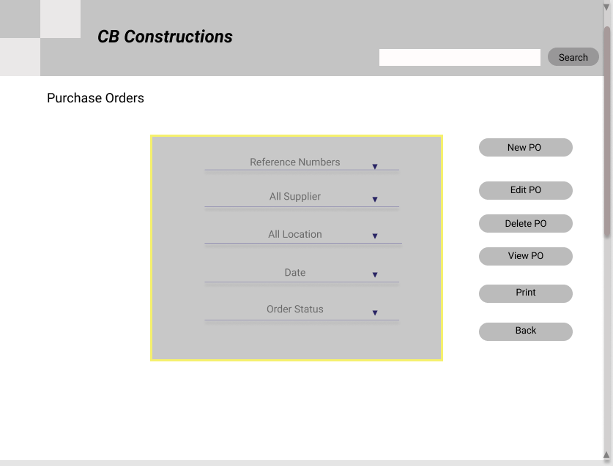

**High Fidelity**

Through this page, user can place edit, view and print Purchase order information.

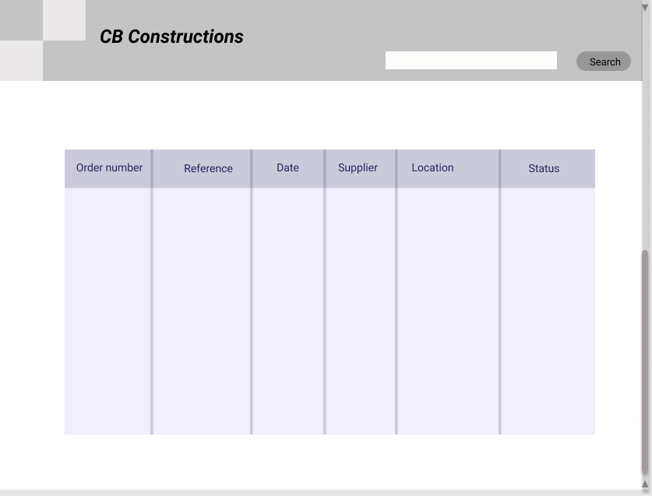

This is the lower part of the Purchase order page. In here, the orders will be displayed in a table.

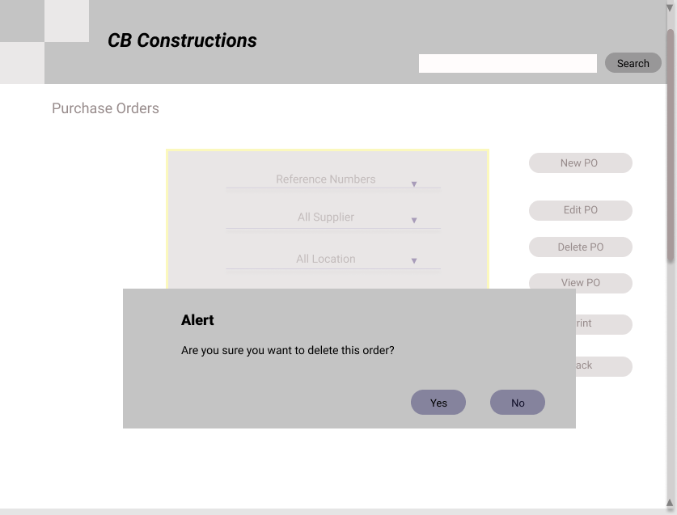

These kind of alerts will be shown when you deleting, approving or rejecting something.

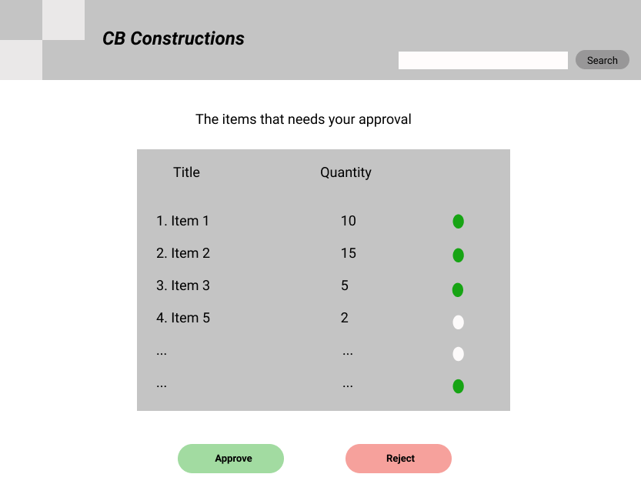

Site manager needs to take approval for the orders before they are placed. This is the page that used to give that approval by a senior staff member.

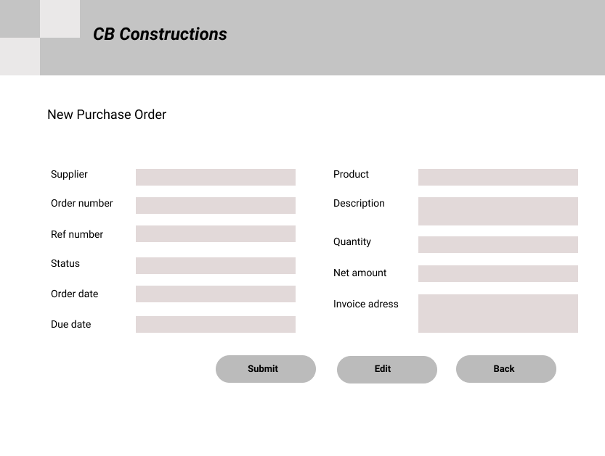

This is the page user can place a new order.

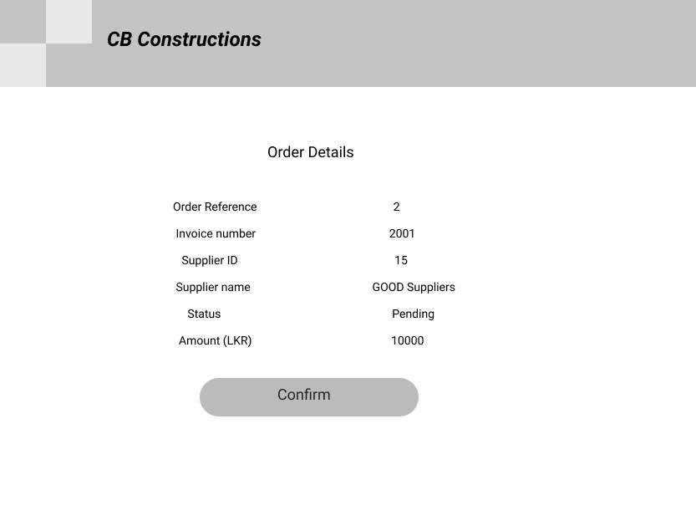

User can view details relevant to a particular order through this page.

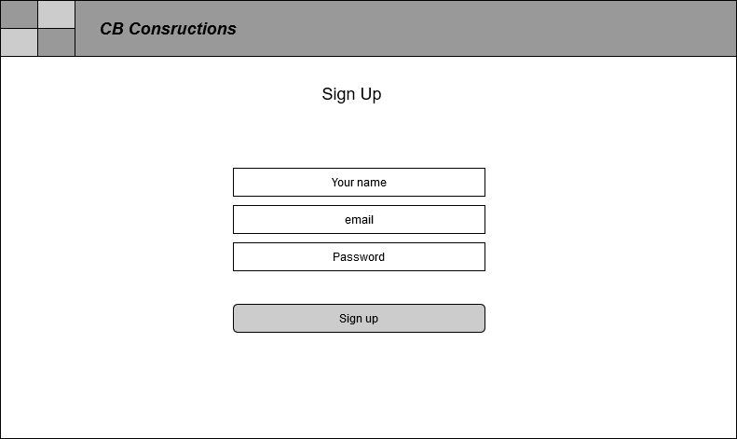

**Low Fidelity**

User need to sign up at first of all, to use the system.

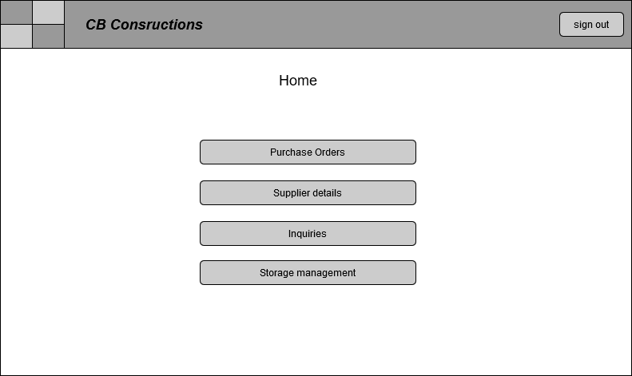

This is the home page of the CB construction system. Though this user can access to the pages they need.

**Assumptions**

1. User first has to login to the system to use it.

2. When the site manager places a new order, it will be sent t to get the approval from the senior staff.

3. When it is approved, the status will be changed to ‘Approved’. Then again site manager has to confirm the order, then an email will be sent to the relevant supplier and user has to change the status according to the supplier’s reply.

ex: If supplier confirmed the order, order status should be changed to pending.

4. Supplier is not a user of the system.

5. When order gets the approval from the senior staff member, status will be changed to 'Approved'. Otherwise, it will be changed to 'Declined'.